BOILER SPECIFICATION
Ref: TS 001 Issue Date: 03.01.17 | Equipment: BOILERS Supplier: HEVAC Ltd.
General Description of Equipment offered for SPECIFICATION /Approval:
- BOILER SPECIFICATION
Drawing: Dims. as per drawing below. |  | Drawing Ref: N/A
DOCUMENTATION ISSUED:
SPECIFICATION | DEDIETRICH FLOOR WALL HUNG GAS CONDENSING BOILER
TYPE | INNOVENS PRO
REF. | MCA45
NOMINAL OUTPUT @ 50/30°C | 43kW
EFFECIENCY @ 100% @ AVG TEMP 70°C | 99.1%
EFFECIENCY @ 30% @ RTN TEMP 30°C | 110.6%
WATER FLOW RATE @ ΔT = 20K | 1.72 m3/h
MIN. NECESSARY WATER FLOW | 0.4 m3/h
MIN. /MAX NOMINAL OUTPUT @ 50/30°C | 8.9-43 kW
MIN. /MAX NOMINAL OUTPUT @ 80/60°C | 8-40.8 kW
GAS FLOW – NAT. GAS | 4.4 m3/hr
GAS FLOW – PROPANE | 1.7m3/hr
MIN / MAX FLUE GAS MASS FLOW RATE | 14/69 kg/h
FLUE GAS PRESSURE AVAILABLE | 150Pa
WATER CONTENT | 5.5 L
NET WEIGHT | 53kg
Triple E No. (ACA) | HWG66561
Energy Efficiency Class in heating | A
Note 1. | Boiler to be wall hung gas condensing
Note 2. | Boiler annual efficiency up to 110%
Note 3. | Boiler to have monoblock heating body in aluminium/silicium
Note 4. | Boiler, gas premix burner in stainless steel with a surface in woven metallic fibres, modulating from 18 to 100% of output.
Note 5. | Boiler fan to be fitted with air intake silencer.
Note 6. | Manufacturer to be DeDietrich as supplied by Hevac Ltd., Muirfield Drive,  Naas Road, Dublin 12. Tel. 01-419 1919
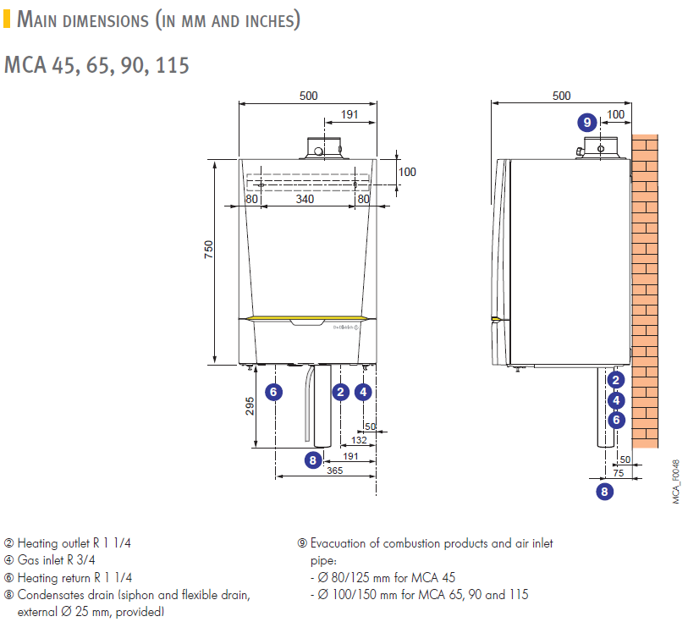

BOILER SPECIFICATION
Ref: TS 001 Issue Date: 03.01.17 | Equipment: BOILERS Supplier: HEVAC Ltd.
General Description of Equipment offered for SPECIFICATION /Approval:
- BOILER SPECIFICATION
Drawing: Dims. as per drawing below. |  | Drawing Ref: N/A
DOCUMENTATION ISSUED:
SPECIFICATION | DEDIETRICH FLOOR WALL HUNG GAS CONDENSING BOILER
TYPE | INNOVENS PRO
REF. | MCA 65
NOMINAL OUTPUT @ 50/30°C | 65kW
EFFECIENCY @ 100% @ AVG TEMP 70°C | 99.2%
EFFECIENCY @ 30% @ RTN TEMP 30°C | 110.4%
NOMINALWATER FLOW RATE @ ΔT = 20K | 2.62 m3/h
MIN. NECESSARY WATER FLOW | 0.4 m3/h
MIN. /MAX NOMINAL OUTPUT @ 50/30°C | 13.3/65 kW
MIN. /MAX NOMINAL OUTPUT @ 80/60°C | 12/61.5 kW
GAS FLOW – NAT. GAS | 6.6 m3/hr
GAS FLOW – PROPANE | 2.5 m3/hr
MIN / MAX FLUE GAS MASS FLOW RATE | 21 / 104 kg/h
PRESSURE AVAILABLE AT BOILER OUTLET | 100Pa
WATER CONTENT | 6.5 L
NET WEIGHT | 60kg
Triple E No. (ACA) | HWG66563
Energy Efficiency Class in heating | A
Note 1. | Boiler to be wall hung gas condensing
Note 2. | Boiler annual efficiency of up to 110%
Note 3. | Boiler to have monoblock heating body in aluminium/silicium
Note 4. | Boiler, gas premix burner in stainless steel with a surface in woven metallic fibres, modulating from 18 to 100% of output.
Note 5. | Boiler fan to be fitted with air intake silencer.
Note 6. | Manufacturer to be DeDietrich as supplied by Hevac Ltd., Muirfield Drive,  Naas Road, Dublin 12. Tel. 01-419 1919

BOILER SPECIFICATION
Ref: TS 001 Issue Date: 03.01.17 | Equipment: BOILERS Supplier: HEVAC Ltd.
General Description of Equipment offered for SPECIFICATION /Approval:
- BOILER SPECIFICATION
Drawing: Dims. as per drawing below. |  | Drawing Ref: N/A
DOCUMENTATION ISSUED:
SPECIFICATION | DEDIETRICH FLOOR WALL HUNG GAS CONDENSING BOILER
TYPE | INNOVENS PRO
REF. | MCA 90
NOMINAL OUTPUT @ 50/30°C | 15.8-89.5kW
EFFECIENCY @ 100% @ AVG TEMP 70°C | 97.9%
EFFECIENCY @ 30% @ RTN TEMP 30°C | 108.1%
NOMINALWATER FLOW RATE @ ΔT = 20K | 3.62 m3/h
MIN. NECESSARY WATER FLOW | 123W
MIN. /MAX NOMINAL OUTPUT @ 50/30°C | 75%
MIN. /MAX NOMINAL OUTPUT @ 80/60°C | 15.8-89.5 kW
GAS FLOW – NAT. GAS | 9.1 m3/hr
GAS FLOW – PROPANE | 3.5m3/hr
MIN / MAX FLUE GAS MASS FLOW RATE | 28/138 kg/h
PRESSURE AVAILABLE AT BOILER OUTLET | 160Pa
WATER CONTENT | 7.5 L
NET WEIGHT | 68kg
Triple E No. (ACA) | HWG66562
Note 1. | Boiler to be wall hung gas condensing
Note 2. | Useful efficiency at 30 % of rated heat output 97.4% GCV  according to commission regulation (EU) n° 813/23013
Note 3. | Boiler to have monoblock heating body in aluminium/silicium
Note 4. | Boiler, gas premix burner in stainless steel with a surface in woven metallic fibres, modulating from 18 to 100% of output.
Note 5. | Boiler fan to be fitted with air intake silencer.
Note 6. | Manufacturer to be DeDietrich as supplied by Hevac Ltd., Muirfield Drive, Naas Road, Dublin 12. Tel. 01-419 1919

BOILER SPECIFICATION
Ref: TS 001 Issue Date: 03.01.17 | Equipment: BOILERS Supplier: HEVAC Ltd.
General Description of Equipment offered for SPECIFICATION /Approval:
- BOILER SPECIFICATION
Drawing: Dims. as per drawing below. |  | Drawing Ref: N/A
DOCUMENTATION ISSUED:
SPECIFICATION | DEDIETRICH FLOOR WALL HUNG GAS CONDENSING BOILER
TYPE | INNOVENS PRO
REF. | MCA 115
NOMINAL OUTPUT @ 50/30°C | 114kW
EFFECIENCY @ 100% @ AVG TEMP 70°C | 97.1%
EFFECIENCY @ 30% @ RTN TEMP 30°C | 108%
NOMINALWATER FLOW RATE @ ΔT = 20K | 4.6 m3/h
MIN. NECESSARY WATER FLOW | 0.4 m3/h
MIN. /MAX NOMINAL OUTPUT @ 50/30°C | 18.4/114 kW
MIN. /MAX NOMINAL OUTPUT @ 80/60°C | 16.6/107 kW
GAS FLOW – NAT. GAS | 11.7 m3/hr
GAS FLOW – PROPANE | 4.7 m3/hr
MIN / MAX FLUE GAS MASS FLOW RATE | 36 / 178 kg/h
PRESSURE AVAILABLE AT BOILER OUTLET | 220Pa
WATER CONTENT | 7.5 L
NET WEIGHT | 69kg
Triple E No. (ACA) | HWG66564
Note 1. | Boiler to be wall hung gas condensing
Note 2. | Useful efficiency at 30 % of rated heat output 97.3% GCV  according to commission regulation (EU) n° 813/23013
Note 3. | Boiler to have monoblock heating body in aluminium/silicium
Note 4. | Boiler, gas premix burner in stainless steel with a surface in woven metallic fibres, modulating from 18 to 100% of output.
Note 5. | Boiler fan to be fitted with air intake silencer.
Note 6. | Manufacturer to be DeDietrich as supplied by Hevac Ltd., Muirfield Drive, Naas Road, Dublin 12. Tel. 01-419 1919

